**Eeg:**

To measure the brain-waves using EEG , reference points are made on the scalp to make sure the electrodes are in the right place . each line that is displayed later shows a different part of the brain measured by a different electrode on the cap that we positioned . the frequency of that EEG is later up for different type of interpretations.

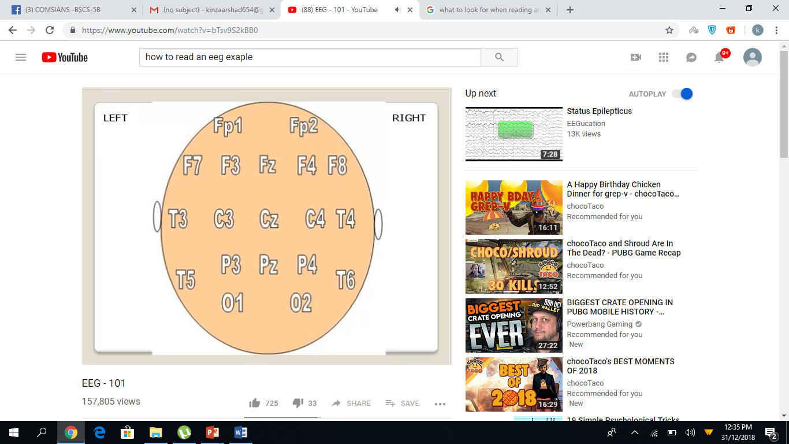

**How to read it:**

**Alpha : (8- <13)**

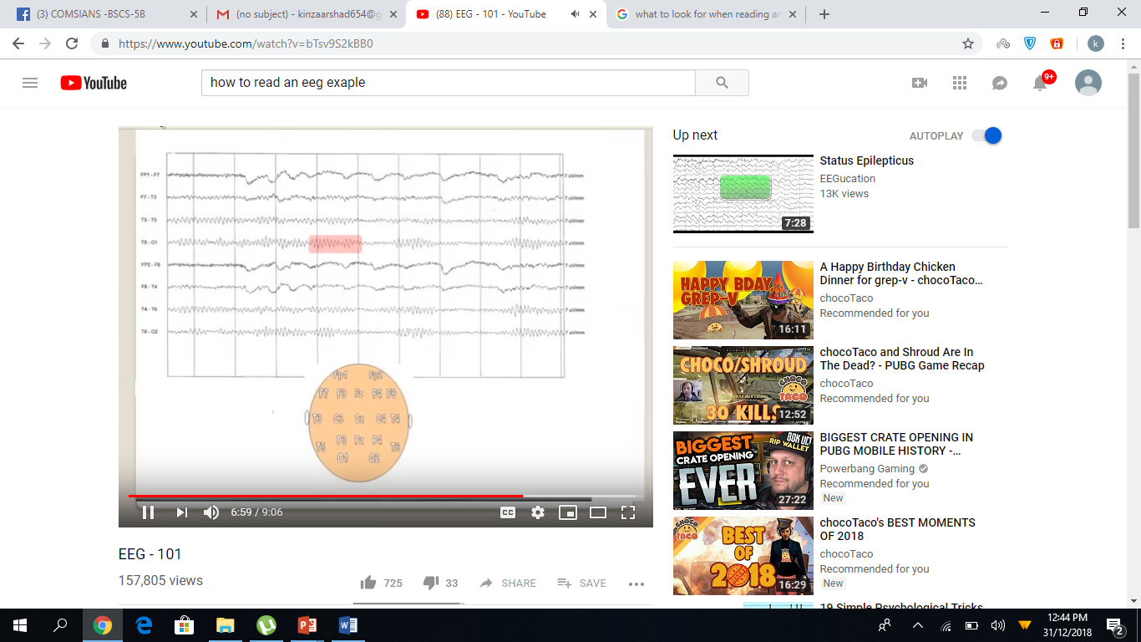

**Beta ( >13 )**

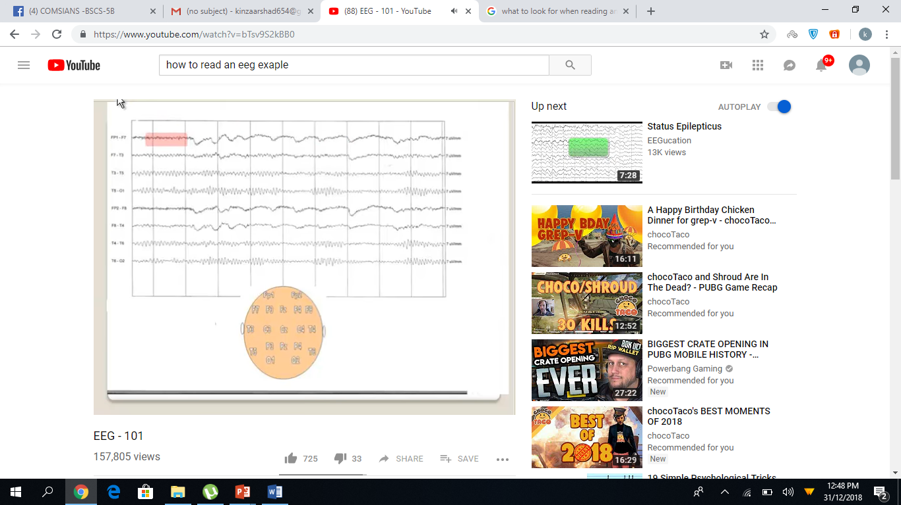

Theta ( 4 - <8)

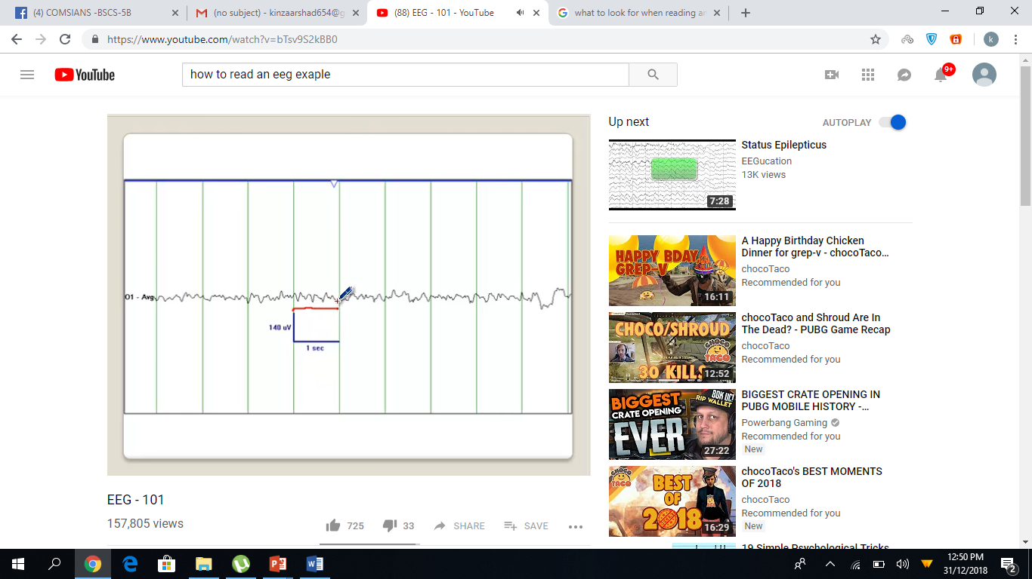

Delta (< 4)

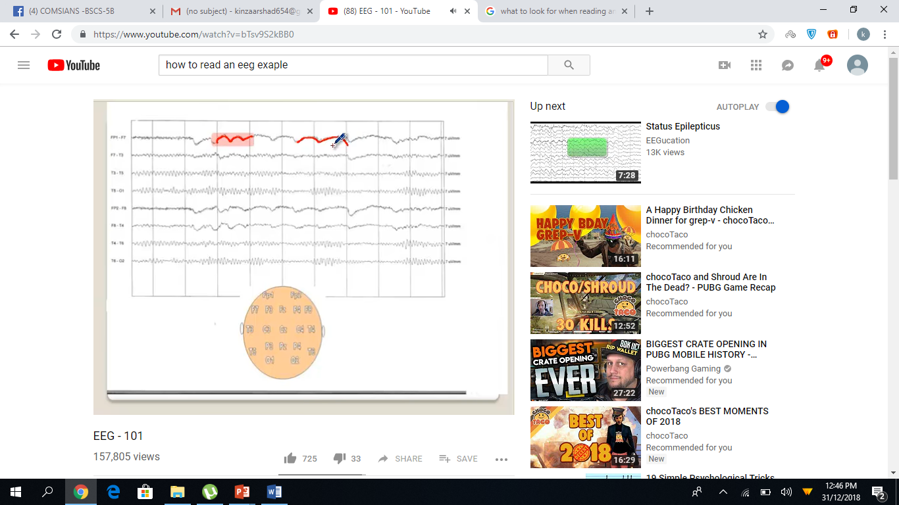

**How to store it in PC:**

There are many difficulties with long-term storage and management of EEG data and metadata.

* There is no software tool for easy EEG data management, which is accessible to the research community.
* There is no EEG data format generally accepted or used by the community.
* Data and metadata are often considered as unimportant for long-term storage and management once their interpretation is completed.
* Metadata are usually not organized.
* There is no practice to share experimental data between various labs. As a result, we have incorporated a set of frequently used data formats and proposed a metadata structure within the development of the EEG system.

**What we plan to do:**

The data is at first stored as a two-dimensional array . separate array is maintained for each electrode . for later use the data is stored in a database . one database is maintained for each subject used for our experiment and recording is stored as a table for each day . data can later be fetched and displayed as a graph.

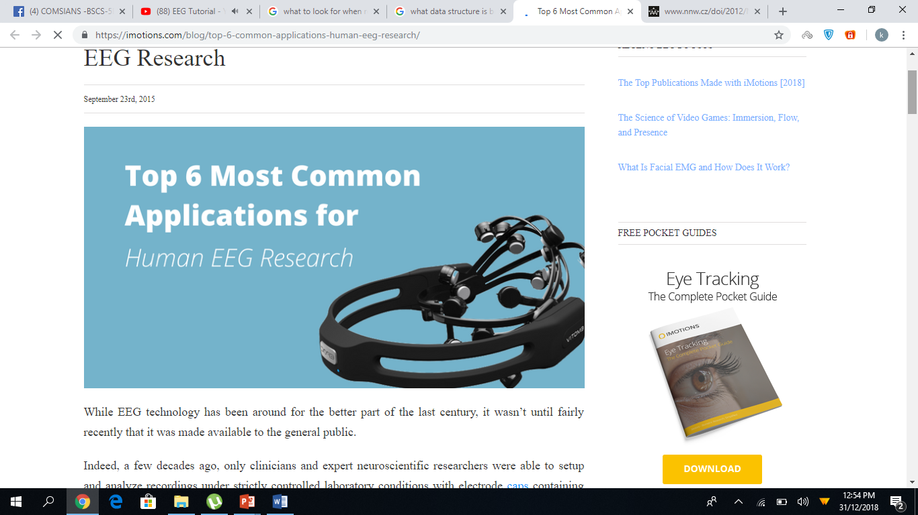

<https://www.quora.com/How-to-insert-a-multidimensional-array-into-a-database>

<https://www.youtube.com/channel/UCKkBiyDw32WGBS3XZHHoHvg>